Maya Soleimani

2/23/2020

Project 1

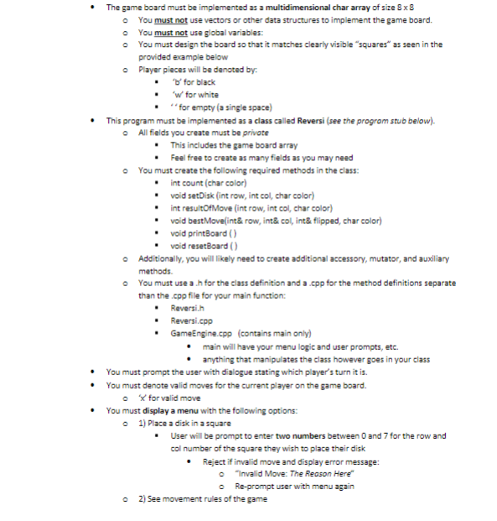

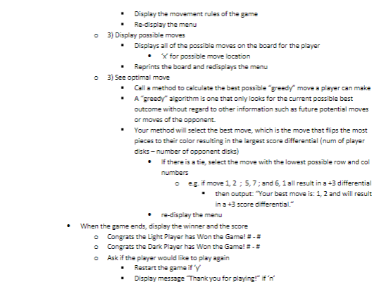

Test Plan: In order to test my program, I will use sample board set-ups for scenarios involving checking direction, emptiness, or where possible moves can be placed (basically creating a faux board to test my conditions).

Program status: Complete.

